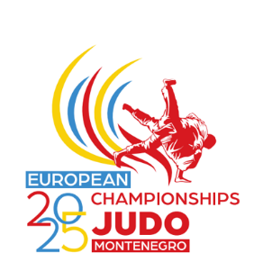
MEMORANDUM

To: All Fighters & Coaches

From: GB Performance Team

Date: 1 April 2025

Subject: GB Selections
2025 Senior European Championships, 23-26 April 2025, Podgorica, MNE

Following a meeting of the Selection Panel, and the subsequent ratification from the Performance Advisory Group (PAG), the following fighters have been selected to represent Great Britain at the 2025 Senior European Championships to be held from 23-26 April 2025, in Podgorica, MNE:

2025 Senior European Championships, 23-26 April 2025, Podgorica, MNE:
Weight: | Name: | Club:
MEN:
Under 66kg | Michael FRYER | Rush Judo
Under 66kg | Charlie YOUNG | Ryecroft Judokwai
Under 73kg | Ben LEVY | Budokwai
Under 100kg | Rhys THOMPSON | Enfield / Team Bath
Under 100kg | Ollie BARRATT | Dragons Academy
Under 100kg RES | Max GREGORY | Drake | RESERVE
WOMEN:
Under 52kg | Tatum KEEN | Bradley Stoke
Under 70kg | Kelly PETERSEN-POLLARD | Hardy Spicer 83
Under 78kg | Emma REID | Redbridge

These selections have been made and announced within the timelines set out in the 2025 Senior European Championships Selection Policy document being week 14, week commencing 31st March.

All selections will be dependent on fighters adhering to the BJA’s Code of Conduct Policy and their ongoing fitness to compete.

All event information including travel schedules will be sent to the GB Delegation in due course.

I am sure you will join us in wishing the fighters every success at this event.

