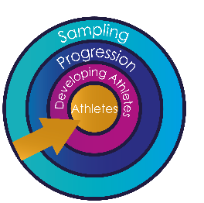
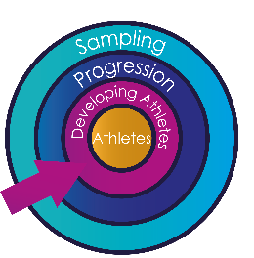
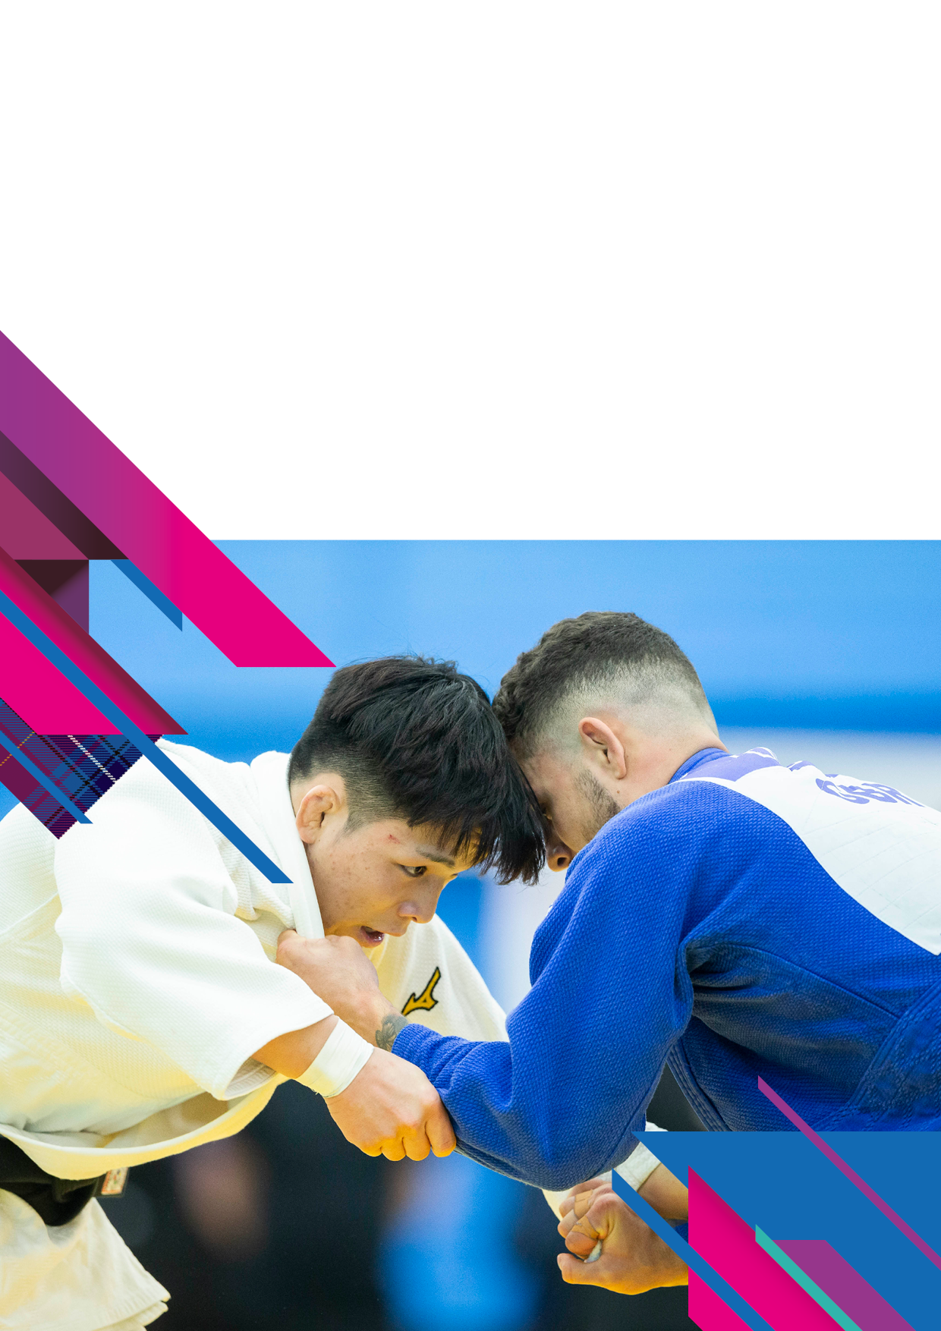

EVENT OUTLINES
Scottish Open Judo Tournament 2025
Saturday 18th January
      - Adapted L1,L2 & Vision Impairment J1, J2 (VI)
      - Veterans
      - Cadets
Sunday 19th January
- Junior
- Senior

Organisers: JudoScotland

Contact Details
- Address: JudoScotland, South Platt Hill, Ratho, Newbridge, EH28 8AA.
- Email: events@judoscotland.com
- Telephone: 0131 333 2981 (JudoScotland Office).
- Tournament Contact: Jo Imrie 07543 287641 (mobile).

Competition Venue: sportscotland National Centre: Inverclyde, Burnside Road, Largs, KA30 8RW.

Dates:
    - Saturday 18th January 2025: Adapted & Vision Impaired judoka will start the day at 9.00am followed by the Veterans & Cadets.
    - Sunday 19th January Juniors will start the day at 8.30am followed by the Seniors,
- Closing Date: All entries and payment must be received by 1200 hours on Friday 3rd January 2025.

Competitor Entry Fee
- Single entry fee: £40.00
- Double entry fee: £70.00
  - For example: Cadet & Junior
- Triple entry fee: £100.00
  - For example: Cadet, Junior & Senior
- Entry fees are non-refundable.
- For a double or triple entry, you must meet the eligibility criteria age, weight & grade specified

Entry Fee/ Payment
JudoScotland Member Judoka
- Booking via www.judoscotland.com.
- When entering, your username is your JudoScotland membership number.
- Telephone entries will be accepted if accompanied by a card payment.

Non-JudoScotland Member Judoka
Entry fee and payment can be made by:
- Telephone entry accompanied by a card payment.
- Completing the 2025 Scottish Open Booking Form.
Please download the booking form to your device before completing it.
- Email your entry form with payment details to events@judoscotland.com.
- Post entry to JudoScotland, EICA Ratho, South Platt Hill, Ratho, Newbridge, EH28 8AA.
- Bank Transfer.
Bank | Account Name | Sort Code | Account Number | SWIFT | IBAN
Bank of Scotland  George Street, Edinburgh,  EH2 3EW | JudoScotland | 80-31-20 | 00812408 | BOFSGB21141 | GB82BOFS80312000812408
When paying, please insert the reference: “SCO OPEN 2025
(Insert “Competitors Name” or if a group booking “Club Name” or “Federation”)

Event Type:

Level 4 Point Scoring: Cadets, Juniors & Seniors
  - Level four events are National and Ranking events. They are designed for experienced players.
  - Coaches support is requested to ensure that Cadets, Juniors, and Seniors are of an appropriate level for a level 4-point scoring event.

Level 3 Point Scoring: Adapted L1, L2 & Vision Impaired J1, J2, (VI) & Veterans
  - Level three events are designed for players who have had substantial experience at Level Two events.

Tournament Rules & Eligibility
- All IJF contest rules will apply; all other rules will be in accordance with the latest BJA Tournament Handbook.
- All competitors must hold and produce proof of current membership to BJA, NIJF, WJA or JudoScotland. It is the judoka’s responsibility to check that their licence is up to date and that they meet the eligibility criteria to compete.
- International competitors must produce proof of membership in their Federation.
- All competitors must be within the specified age, grade & weight limits for their category.
- A competitor will be allowed to enter two/three sections if they are within the age, weight & grade specified:
For Example: A player may, if eligible, compete in cadet, junior & senior event.
- If you are uncertain of your eligibility, please contact Jo Imrie on telephone: +44 (0)131 333 2981, Option 2: Events

Judogi
- The wearing of white & blue Judogi is COMPULSORY for this event (For Cadets, Junior, and Seniors).
- Veterans, Adapted & Vision Impaired white suit only with blue and white belts.

Weigh-In
If you have entered into two or more categories, you only need to weigh-in once.
E.g. if you are competing in cadet and juniors categories, you will only need to weigh-in at cadets, your weight will be carried forward to juniors.

Veterans weigh-in will be held on Friday 17th January 2025 at the competition venue
  - Test Scales will be available from 16.30 to 17.00 hours.
  - Official weigh-in 17.15 to 18.00 hours.
Veterans can also weigh-in on Saturday 18th January 2025 at the competition venue
  - Test Scales will be available from 07.00 hours.
  - Official weigh-in 07.15 – 07.30 hours.
  - Veterans only need to attend one weigh-in.

Adapted & Vision Impaired (VI) weigh-in will be held on Friday17th January 2025 at the competition venue.
  - Test Scales will be available from 16.30 to 17.00 hours.
  - Official weigh-in 17.15 to 18.00 hours.
  - Divisioning for Adapted and Vision Impaired players will take place on Friday 17th January 2024 at 18.15.

Cadets weigh-in will be held on Saturday 18th January 2025 at the competition venue.
  - Test Scales will be available from 10.00 hours.
  - Official weigh-in 11.00 to 11.30.

Juniors weigh-in will be held on Saturday 18th January 2025 at the competition venue.
  - Test Scales will be available from 16.30 to 17.00 hours.
  - Official weigh-in 17.15 to 18.00 hours.

Seniors weigh-in will be held on Saturday 18th January 2024 at the competition venue.
  - Test scales will be available from 18.00 to 18.45 hours.
  - Official weigh-in 18.45 to 20.00 hours.
- Senior categories will commence on the near completion of the Junior categories.
- Please notify the organisers of any weight change at weigh-in.
- Competitors must arrive at their designated weigh-in times.

Weight Allowance:
This event has an open weigh-in. Judokas must wear a T-shirt/Rash Guard when weighing-in.

Females & Males weight allowance 0.8kg
- Females and Males must wear a white round neck collar T-shirt/Rash Guard, with competition legal judogi trousers for weigh in.
- Females must wear a white round neck collar T-shirt/Rash Guard, with their judogi in competition
- Males can choose to wear a white round neck collar T-shirt/Rash Guard, with their judogi in competition.
- Players must satisfy the minimum weight limit for their category, e.g., U66 kg player must weigh a minimum of 60.9 kg.

T-Shirt Criteria
The standard T-shirt / Rash Guard worn in all categories will be plain white with a round neck collar and have a maximum sleeve length up to 5cm above the wrist joint. There will be no advertising on the T-shirt / Rash Guard of any description other than the standard manufacturers label, maximum size of manufacturers label will be 3cm x 15cm and not visible when the jacket is tied in its normal position. Should a T-shirt / Rash Guard become damaged or soiled to such a degree that the referee decides it requires changing, an appropriate official of the category gender will accompany the athlete to do so. The athlete will not be left on their own during this process. Any changing must be conducted in a changing room irrespective of age

Weight Categories
Cadets: 2008/2009/2010 - Contest Times: 4 minutes with unlimited golden score, minimum grade orange belt. Strangles and Armlocks Permitted
  - Female: U40kg, U44kg, U48kg, U52kg, U57kg, U63kg, U70kg, O70kg
  - Male: U42kg, U46kg, U50kg, U55kg, U60kg, U66kg, U73kg, U81kg, U90kg, O90kg

Juniors 2005/2006/2007/2008/2009/2010 - Contest Times: 4 minutes with unlimited golden score, minimum grade blue belt. Strangles and Armlocks permitted.
  - Female: U44kg, U48kg, U52kg, U57kg, U63kg, U70kg, U78kg, O78kg
  - Male: U55kg, U60kg, U66kg, U73kg, U81kg, U90kg, U100kg, O100kg

Seniors 14 years or older on the day of competition - Contest Times: 4 minutes with unlimited golden score, minimum grade blue belt. Strangles and Armlocks permitted.
  - Female: U48kg, U52kg, U57kg, U63kg, U70kg, U78kg, O78kg
  - Male: U60kg, U66kg, U73kg, U81kg, U90kg, U100kg, O100kg

Veterans 30 years of age @ 31st December 2025 – you will be put into the category which reflects your age at 31st December 2025, minimum grade orange belt.

M1/M2  F1/F2 | M3/M4  F3/F4 | M5/M6  F5/F6 | M7+  F7+
30-39 | 40-49 | 50-59 | 60+
3 minutes and unlimited golden score |  |  | 2.30 minutes and 1 minute golden score
Strangles and Arm locks permitted |  |  | No strangles allowed

- Female – U48kg, U52kg, U57kg,U63kg, U70kg, U78kg, O78kg
  - Male – U60kg, U66kg, U73kg, U81kg, U90kg, U100kg, O100kg

Please note: Categories may be merged, to ensure meaningful competition, prior notification be given after the closing date where possible.

Adapted L1, L2 & Vision Impaired J1, J2 (VI): 14 years or older on day of the competition: Contest Times: 3 minutes with unlimited golden score, minimum grade green belt.
  - Female: U52kg, U57kg, U63kg, U70kg, U78kg, O78kg
  - Male: U60kg, U66kg, U73kg, U81kg, U90kg, U100kg, O100kg

Please note: Categories may be merged, to ensure meaningful competition, prior notification be given after the closing date where possible.

Adapted Classification:
Level 1 (L1): A judoka who can perform in a shiai with a mainstream recreational/competitive judoka. This judoka is fast and powerful and has excellent reactivity. They has a strong feeling for Judo and an excellent strategic view. This judoka has a good understanding of the meaning and goal of the competition on and is capable of participating in mainstream regional, national and international competitions.
Level 2 (L2): A judoka who can train and take part in light competition (RANDORI) with mainstream players.
This Judoka understands the meaning and goal of the competition and is capable of taking part in mainstream local competitions and tournaments. This judoka is fast and powerful and has moderate reactivity but is usually late responding to judo situations. They has a good judo feeling but may struggle with processing complex instructions.
https://www.britishjudo.org.uk/wp-content/uploads/2023/10/Tournament-Handbook-2023-Final-Oct-23a.pdf (page 38)
BJA Adaptive Contest Rules will apply:
https://www.britishjudo.org.uk/wp-content/uploads/2018/02/2018-BJA-Adaptive-Contest-Rules.pdf

Vision Impairment Criteria

J1: The Athlete’s Vision Impairment must result in a visual acuity of less than or equal to LogMAR 2.6 in binocular vision.

J2: The Athlete’s visual acuity must be within a range between LogMAR 1.3 and 2.5 with binocular vision, or with a binocular visual field of 60 degrees or less in diameter.
https://ibsajudo.sport/about-judo/classification/

Additional criteria:
- If Adapted judoka and Vision Impaired judoka are combined categories strangles and armlocks are not permitted.
- If there is a category consisting only of Vision Impaired judoka, strangles and armlocks are permitted.
- Judoka must have previous engagement / participation in level 3 events to ensure competency.
- Divisioning will be undertaken to ensure appropriate judo ability, the following system for divisioning will be in place.

Please note: Categories may be merged, to ensure meaningful competition, prior notification be given after the closing date where possible.

JudoScotland Adapted & Vison Impaired Judoka Divisioning Criteria

Sport-specific divisioning in Judo is crucial for fostering fair competition and maximising athletes' potential. By categorising participants based on weight, skill level, age, and gender, divisioning ensures balanced matches, reducing the risk of injury and promoting safety. It allows judokas to compete against peers of similar abilities, enhancing the competitive experience and encouraging skill development. This tailored approach supports athletes' confidence and progression, making the sport more inclusive and accessible. Moreover, it helps in identifying talent and potential at various levels, ultimately contributing to the overall growth and excellence in the sport of Judo. JudoScotland aims to implement a divisioning system that is both fair and specific to Judo, ensuring a clear understanding of athlete categorization. Our primary objectives are safety, fairness, and the overall quality of the event.
Judo Movement | Judo Nage Komi | Judo - Randori | Judo - Terminology
Judoka must demonstrate | Judoka must demonstrate | Judoka must demonstrate | Judoka must demonstrate
Ukemi - forward/ back wards | Two standing forward techniques of their choice. | One minute randori style practice. Randori practice must incorporate Tachi Waza and Newaza | Understanding of Judo terminology and contest rules
Tsugi Ashi movement around a designated area | Two standing combination techniques using Ashi Waza of their choice
Shadow Uchi Komi movement incorporating forward, backward and combination techniques | One standing combination technique linked Nezawa technique
JudoScotland aims to implement a divisioning system that is both fair and specific to Judo, ensuring a clear understanding of athlete categorisation. Our primary objectives are safety, fairness, and the overall quality of the event. In terms of safety, JudoScotland’ s divisioning assessors have the right to halt any stage of the assessment if they believe a player is at risk.

Random Weight Check
- Junior & Seniors normal weigh in rules will apply, names will be displayed/posted on the JudoScotland website and JudoScotland telegram an hour before the start of the competition.
- The weight of the athlete cannot be more than 5% higher (without Judogi) than the official maximum weight limit of the category.

Seeding
- There will be seeding in the Cadet, Junior and Senior categories, which will be based on the current British Ranking list.

Medals
  - 4 Medals will be awarded in each category where numbers permit.
    - Competitors must have won at least one contest to be eligible for a medal.
  - The organisers reserve the right to combine age/weight categories when appropriate.
  - Veteran’s, Adapted & Vision Impairment (VI), Cadet and Junior and medals will be presented throughout the day.
  - Senior medals will be presented after the final block has concluded.

Coaches and Mat-Side Coaching
- Scottish coaches must apply for a coaching pass by registering via www.judoscotland.com and selecting the coaching pass ticket, prior to the closing date of 1200 hours on Tuesday 14th January 2025
- Other home nations and international coaches must email events@judoscotland.com and attach a copy of your coaching card, to apply for a coaching pass ticket, prior to the closing date of 1200 hours on Tuesday 14th January 2025.
- Coach registration will be checked with the relevant Governing Body and only coaches that have met the criteria will be allowed mat side.
- Coaching passes are non-transferrable.
- Coaches must adhere to the code of conduct for coaches a copy of which will be provided at coach accreditation.
  - Coaches must ensure that they attend the coaches briefing prior to the commencement of the event. The referee in charge will give a briefing on any updates.
- Coaching booths will be used, only one coach per player.

Venue Facilities
- Small café onsite
- Free car parking (limited spaces, but on street parking is available)
- No cash machine.

Spectator Ticketing
- Spectator Fee: £5.00, no spectator charge for children (under 16).
- Spectator entry is available from 0800 hours.
- Spectators do not gain access to mat-side.

Passenger Transfers from Glasgow International Airport Only
- Transfers can be booked between Glasgow International Airport and the tournament venue/ official accommodation only.
- Transfers will be offered only to those participants who book their accommodation via the organiser in advance.
- Transportation from Glasgow International Airport to the sportscotland National Centre: Inverclyde, will be charged at £30.00 per person for a return journey.
- Pick Up Times:
  - Friday 17th January 12.00(noon), 15.00, 18.00 hours
  - Saturday 18th January 13.00 hours
- Return Trips will be as follows:
  - Saturday 18th January 19.00 hours
  - Sunday 19th January 19.00 hours
- No other transfers will be available outside of these dates and times.
- Transfers & Accommodation can be booked by downloading the booking form 2025-Scottish-Open-Entry - Accommodation- Transfer -Booking-Form and filling out the relevant information to you.

Transport Links
- Glasgow International Airport, Paisley PA3 2SW (24miles).
- Prestwick International Airport, Prestwick KA9 2PL (28miles)
- The nearest train station to the venue is Largs Train Station (1.2miles).
- Bus Links from Glasgow City Centre via Clyde Flyer.

Accommodation
sportscotland National Centre: Inverclyde
- Twin-bedded accommodation at the sportscotland National Centre: Inverclyde, is offered on a first come, first served basis:
Price per person/night
Twin Room (Sharing) Bed & Breakfast | £55.00
Twin Room (Sharing) with Half Board (Breakfast & Dinner) (Competitions Days) | £75.00

- Accommodation can be booked by downloading the booking form here 2025-Scottish-Open-Entry - Accommodation- Transfer -Booking-Form and filling out the relevant information to you.
- Other accommodation within easy travelling distance of the event venue can be booked via:
  - www.visitscotland.com or;
  - www.booking.com.
  - Injuries, visa problems or sickness will not be considered valid reasons for cancellation of accommodation.
  - JudoScotland will not cover expenses or cancellation fees under any circumstances.

Cancellation Policy (Accommodation Only)
- Up to 30 days before arrival: No charge
- 29-15 days before arrival: 50% refund
- Less than 15 days: No refund
  - In case of damage to accommodation, competition venue or transportation the individual(s) responsible will be invoiced.

Pre & Post event training opportunities
Day and Date | Morning Session | Evening Session | Cost | Where
Monday 13th January | 0900 hours | No session | No Charge | JudoScotland  National Training Centre  South Platt Hill  Newbridge  Ratho  Edinburgh  EH28 8AA
Tuesday 14th January | No session | 19.00 hours | No Charge
Wednesday 15th January | 0900 hours | No session | No Charge
Thursday 16th January | No session | 19.00 hours | No Charge
Friday 17th January | 0900 hours | No session | No Charge
Monday 20th January | 10.00 hours | 19.00 hours | No Charge
Tuesday 21st January | 10.00 hours | 19.00 hours | No Charge
Wednesday 22nd January | 10.00 hours | No session | No Charge

General
Using Your Personal Information
We will use the information provided on this form so that we can: process your entry or booking for a course, event, or competition; and to communicate with you in relation to your attendance at that event. The full JudoScotland Privacy Notice can be viewed at: www.JudoScotland.com.
- Although age and weight categories are in place, it may be necessary to combine categories on the day.
- Video recording and photography of the activities may take place at this event and may be used for promotional purposes including publication on websites and social media.
- By entering you indicate your acceptance of these conditions and parents (in the absence of any expressed objection) provide their consent to the taking and use of photos/videos.
- The decision of the Event Organiser is final.
- The event is run in line with the JudoScotland/BJA Child Protection Policy.
- All information supplied will only be used for event organisation purposes.
- All EU competitors must make themselves aware of the changes to the immigration policy.
- If you have any concerns on the day regarding judoka welfare, please speak with our Lead Wellbeing and Protection Officer Luke Struthers or alternatively he can be contacted by email safeguarding@judoscotland.com or Telephone 07495836223.
- JudoScotland standby Safeguarding and Wellbeing Officer at this event is Jo Imrie.

