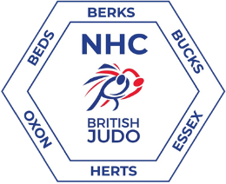

NORTHERN HOME COUNTIES AREA KODOKAN GOSHIN-JUTSU KATA COURSE OPEN TO All

Date: Sunday 8th January 2023

Booking in: 9.30 am to 10 am

Course: 10 am to 3pm

Cost: £20

Venue: The Royal British Legion
Whielden Street
Amersham
Buckinghamshire
HP7 0JD

This will be a BJA Coaching Re-validation Event: Closing Date: Wednesday 4th January 2023

Course restricted to14 players due to a limited mat area. White Judogi and bring a packed lunch. (Demonstration weapons will be supplied for the duration of the course).

Please pay by Bank transfer to: BJA NHC 40-38-04 25193966

PLEASE NOTE: Contact Paul Jordan first on Enquiries to confirm availability of places on this course before paying to avoid any disappointment. Please include your name and details then return the slip below to: NHC Kata Lead. 96 Underwood Road High Wycombe Buckinghamshire HP13 6YA

ENQUIRIES: Paul Jordan on 07746 572527 or Email: pauljor61jc@hotmail.co.uk

Click here to access the online entry to the course.

Date: 08/01/2023 Kodokan Goshin-Jutsu kata course: This is a BJA coaching re-validation event. Certificate of attendance will be handed out at the end of the course Total cost £20.

Name: Licence No:

Address: Grade:

Telephone No:

Email Address:

