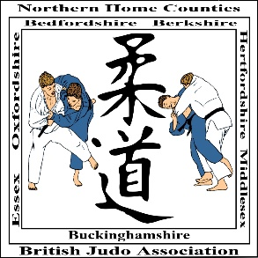
N.H.C. ORANGE BELT & BELOW OPEN FOR BOYS & GIRLS
Novice to 9th Mon inclusive - This is a Level 2 Event
PLAYERS 8 YEARS TO 15 YEARS INCLUSIVE
EVENT DATE: SUNDAY 3 MARCH 2019
CLOSING DATE: SATURDAY 23 FEBRUARY 2019

VENUE:
High Wycombe Judo Centre
Barry Close
Booker, High Wycombe
Buckinghamshire HP12 4UE

www.nhcjudo.org

THIS EVENT IS AGE BANDED
ARMLOCKS & STRANGLES ARE NOT PERMITTED
‘WHITE JUDO SUITS SHOULD BE WORN’

Players MUST be aged 8 years to 15 years inclusive on date of event and MUST comply with the following:

All Competitors MUST hold a current membership licence

NO LICENCE – NO CONTEST – NO EXCEPTIONS

GROUP A : 8 – 11 YEARS INCLUSIVE
TECHNICAL RESTRICTIONS WILL APPLY

BOYS: -24kg, -27kg, -30kg, -34kg, -38kg, -42kg, -46kg, -50kg, +50kg

GIRLS: -25kg, -28kg, -32kg, -36kg, -40kg, -44kg, -48kg, -52kg, +52kg

WEIGH-IN TIMES GROUP A
GIRLS: U25kg, U28kg, U32kg, U36kg - 08:00am to 08:45am
BOYS: U24kg, U27kg, U30kg, U34kg - 08:00am to 08:45am
ALL OTHER WEIGHTS - 11:00am to 11:30am

GROUP B : 12 – 15 YEARS INCLUSIVE

BOYS: -34kg, -38kg, -42kg, -46kg, -50kg, -55kg, -60k, -66kg, +66kg

GIRLS: -32kg, -36kg, -40kg, -44kg, -48kg, -52kg, -57kg, -63kg, +63kg

WEIGH-IN TIMES – GROUP B
ALL WEIGHTS – 12:00 noon to 1:00pm

Competition Method: Compound Knockout – Numbers Permitting
The organisers reserve the right to combine weight groups should the entries
warrant this

ENTRY FEE: £16.00 per competitor - Non-refundable unless proof of injury/illness supplied
cheques payable to BJA NHC

SPECTATOR FEE: £3:00 per adult payable on the day – (U16’s and OAP’s – Free of Charge)

Postal Entries to:

------------------------

Entry via on-line: http://onlineentries.co.uk/nhc
(click on the event you wish to enter)

COACHES

One Club Coach per club per mat area will be permitted free entry on
production of their VALID BJA Coach Award card
Please supply names of nominated club coaches

All other Club Coaches will be permitted a concession rate of £3 entry fee on production of a VALID BJA Coach Award Card

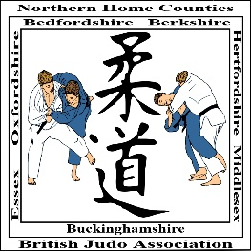
N.H.C. ORANGE BELT & BELOW OPEN FOR BOYS & GIRLS
Novice to 9th Mon inclusive - This is a Level 2 Event
PLAYERS 8 YEARS TO 15 YEARS INCLUSIVE

ENTRY FORM

VENUE
High Wycombe Judo Centre, Barry Close, High Wycombe HP12 4UE

www.nhcjudo.org

TECHNICAL RESTRICTIONS WILL APPLY TO THIS EVENT

ARMLOCK & STRANGLES ARE NOT PERMITTED

EVENT DATE: SUNDAY 3 MARCH 2019
CLOSING DATE: SATURDAY 23 FEBRUARY 2019

ENTRY FEE: £16.00 Non-refundable unless proof of injury/illness supplied

Cheques payable to BJA NHC

Postal Entries to:
------------------------

Entry via on-line: HTTP://onlineentries.co.uk/nhc
(click on the event you wish to enter)

FIRST NAME………………………………….SURNAME………………………………………….

ADDRESS…………………………………………………………………………….........................

………………………….……….. POST CODE………………………………. MALE / FEMALE
(PLEASE CIRCLE)

TELEPHONE NO……………………............. EMAIL………………………………………………
Please confirm receipt of entry

CLUB………………………………………….. GROUP .............................................................

WEIGHT…………………………………Kg GRADE…………………...………………………….

LICENCE NO……………………………..…. DATE OF BIRTH……………………...…………...

NAME/ OF NOMINATED CLUB COACH/COACHES………………………………………………
2 only this event – 1 per mat area

