
JudoScotland National Kyu and Dan Grading
&
JudoScotland Masters National 1st Kyu and Dan Grading
Ravenscraig Regional Sports Facilities, 1 O’Donnell Way, Motherwell, ML1 2TZ
Sunday 14th March 2027

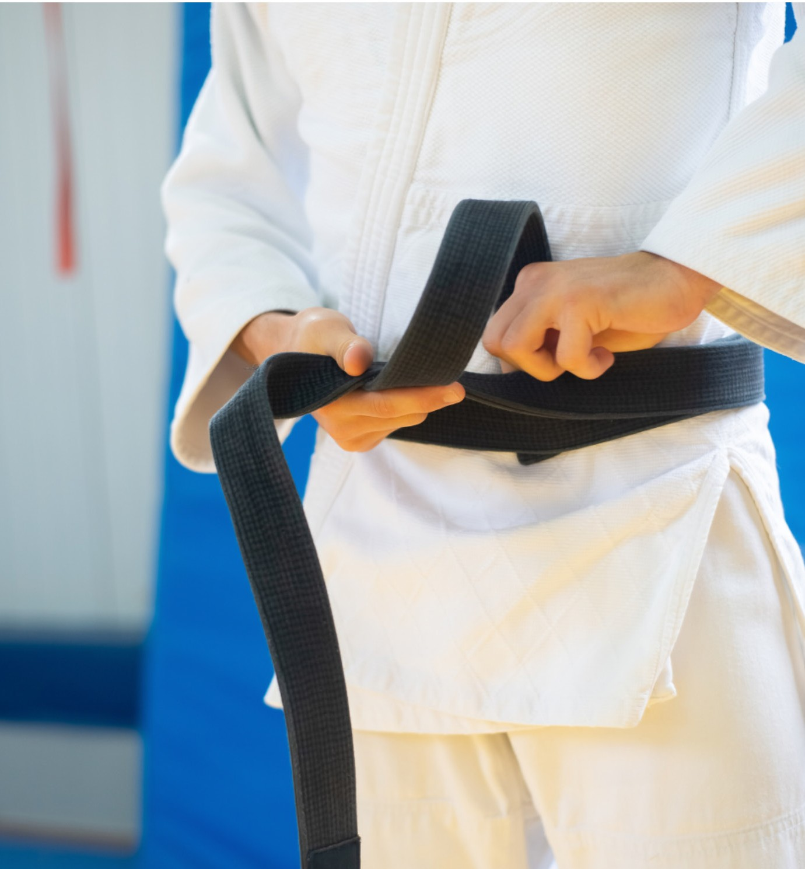

Organiser

Contact Details
Address: JudoScotland, EICA Ratho, South Platt Hill, Ratho, Newbridge, EH28 8AA.
Email: events@judoscotland.com.
Telephone: 0131 333 2981 (JudoScotland Office.)
Emergency Contact: 07543 287 451 (Jo Imrie.)
Venue
Ravenscraig Regional Sports Facilities, 1 O’Donnell Way, Motherwell, ML2 1TZ
Dates
Grading Date: Sunday 14th March 2027
Closing Date: All entries and payment must be received by 1200 hours on Friday 12th March 2027
Entry Fee
- Dan Grades no theory (1st Kyu and above) £30.00
- Dan Grades with theory (1st Kyu and above) £35.00
- Competitive Dan Grade (1st Kyu and above) (theory only) £15.00

Entry/Payment
Telephone entries will be accepted if accompanied by a card payment.
JudoScotland members can enter online – www.judoscotland.com.

Grading Timetable
THEORY EXAMS
9-10:45AM
COMPETITIVE CHECK IN
10-10:45AM
FORMAL BOW WITH THEORY AWARDS & WELCOME 11AM
PRELIMINARY CONTESTS

DAN GRADE PROMOTIONAL LINE UPS

Eligibility
- Judoka must be 15 years or older to take part in a competitive grading.
- Judoka can be 14 years or older to take part in theory only.
- Judoka must be 30 years or older to take part in the Masters section.
  - Masters Male 30+ - 1st Kyu & all Dan Grades
  - Masters Female 30+ - 1st Kyu & all Dan Grades
- If your current grade is a technical Dan Grade, you will need to compete with your previous competitive grade.
- All players must have a current up-to-date Judo membership.
- It is the Judoka’s responsibility to check that their licence is in date and that they meet the eligibility criteria to compete.
- If you are uncertain of your eligibility, please contact our events manager on :0131 333 2981
Judogi
- The wearing of WHITE judogi is compulsory for this event.
- Competitors must have their own blue and white belts
- Competitors must always wear suitable footwear and clothing when off the mat.
Registration & Weigh-in
- Registration & weigh-in will take place on Sunday 14th March 2027
- At registration players must show that their record book meets the minimum grade criteria.
- All weight categories will take place in an open weigh-in.
- All players MUST weigh-in wearing competition acceptable judogi trousers and T-shirt.
- Players are ONLY permitted to change in the designated official changing rooms.
- The use of mobile phones is strictly not permitted within the changing rooms.
General Information
- Video recording and photography may be taken for promotional purposes including publication on websites and social media. By signing the entry form you indicate your acceptance of these conditions and parents (in the absence of any expressed objection) provide their consent to the taking and use of photos/videos.
- The Decision of the Event Organiser is final.
- The event is run in line with JudoScotland/BJA Child Protection Policy.
- The information supplied will only be used for event organisation purposes.

Welfare and Safeguarding:

- The event will be run in accordance with the JudoScotland / BJA Child Protection Policy.
- Information poster about our event Wellbeing and Protection Officer will be displayed throughout the venue.
- If you have any concerns about judoka welfare on the day, please contact safeguarding@judoscotland.com Or you can also report it through British Judo MyVoice

Liability
- JudoScotland shall not be liable for any delay or failure to perform any obligation, or for any alterations/cancellations, due to causes beyond its reasonable control. These may include, but are not limited to:
  - Venue closure
  - Strikes, lockouts, or labour disputes
  - Acts of God (e.g. war, riot, civil unrest, terrorism, etc.)
  - Threats to safety, compliance with government laws or orders
  - Environmental contamination, pandemics, disease outbreaks
  - Equipment failure, fire, flood, storm
  - Shortage or increased cost of staff, materials, or goods
Refund Policy
Entry Fees:
- Refunds will only be issued if requested before the official closing date of the event. No refunds will be considered after this date. Administrative fees may apply.

Additional Information
- By entering and/or attending this event you agree to abide by all British Judo Association policies and codes of conduct.
- This includes but is not limited to:
- Transgender policy https://www.britishjudo.org.uk/what-we-do/policies/transgender-eligibility-and-participation-in-competition-policy/
- Codes of conduct https://www.britishjudo.org.uk/membership-terms-conditions/
- Contest rules https://www.britishjudo.org.uk/compete/organising-a-competition/contest-rules/
- ohttps://www.britishjudo.org.uk/roles-and-clubs/roles/referees/resources/
- Stoma bags: https://www.britishjudo.org.uk/participation-in-competition-with-stoma-bags/
- Prosthetic limbs: https://www.britishjudo.org.uk/participation-in-competition-with-prosthetic-limbs/
- You must contact the organisers and events@bririshjudo.org.uk if you require any support at the event or have any questions regarding the above points.
- Please note that failure to comply with these policies and codes of conduct may result in not being able to compete/attend this event, or removal from the event, and notification to the British Judo

